CENWP-OD-B 16 July 2024

MEMORANDUM FOR THE RECORD

SUBJECT: 24BON029 MFR Adult Fish Facility Sockeye Mortality

On the morning of 16 July, CRITFC biologists notified Project Biologists of a Sockeye mortality. Upon scanning the fish for PIT tags it was found that it had been tagged in Bonneville’s Adult Fish Facility earlier that day.
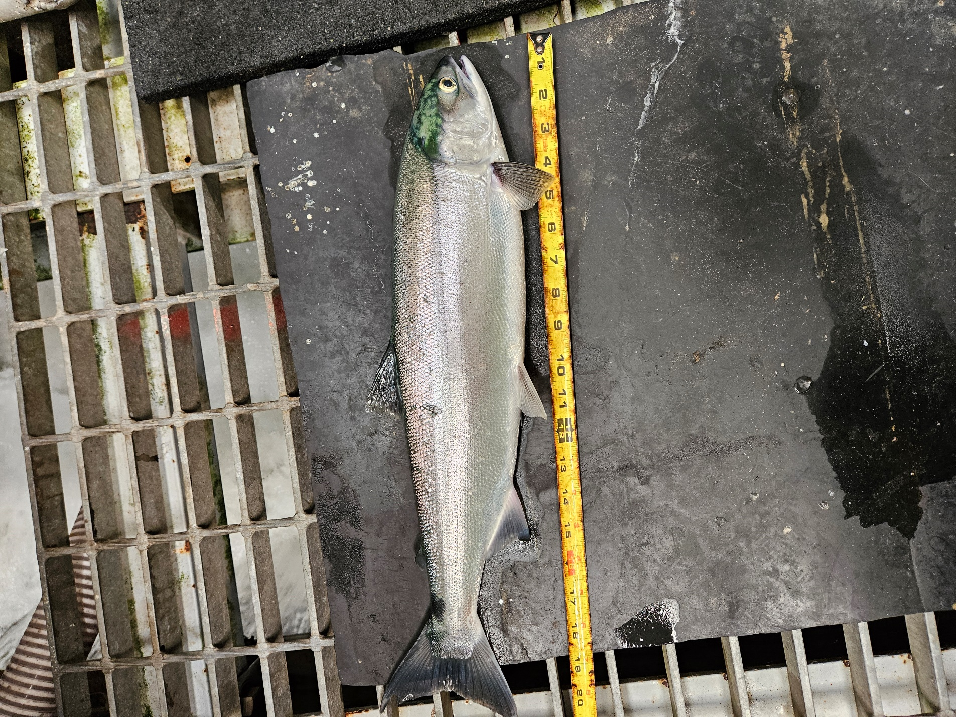
- Species – Chinook (Oncorhynchus nerka)
- Origin – Unknown
- Length – Approximately 53.3 cm.
- Marks and tags – PIT tag 3DD.003E28DF2C
- Marks and Injuries found on carcass – none
- Cause and Time of Death –
- Future and Preventative Measures – none

Sincerely,
Bonneville Project Fisheries

